**NOTE:** I tried to be overly inclusive rather than not inclusive enough. For example, I included a lot of integrals and derivatives that are simply on the equation sheet, but I figured it can’t hurt to know some of the basic Physics 1 equations that are utilized in calculus ways. Good luck and as always let me know if there’s anything I can do to help!

AP Physics C Additional Topic List

* Unit 1: Kinematics
  + Going back and forth between position, velocity, acceleration functions using integrals, differential equations, and derivatives
  + Relative velocity
  + Range equation: R= v02sin2𝞗

g

* Unit 2: Forces and Circular Motion
  + Drag forces as a function of velocity (f=-kv or f=kv2)
  + F=ma ←> using calculus on x(t), v(t), a(t) functions
  + Circular motion: cars on banked (sloped) curve. Centripetal force is Nsin𝞗
* Unit 3: Work, Energy, Power
  + 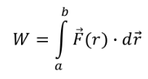
  + 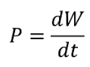
  + Conservative forces:
    - 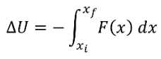
  + U vs. x graphs and potential wells
* Unit 4: Momentum
  + Calculating center of mass
    - 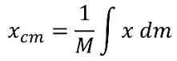
    - 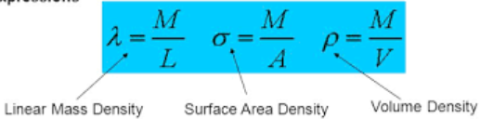

 

* 
* 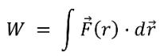
* Two dimensional conservation of momentum
* Unit 5: Rotation
  + 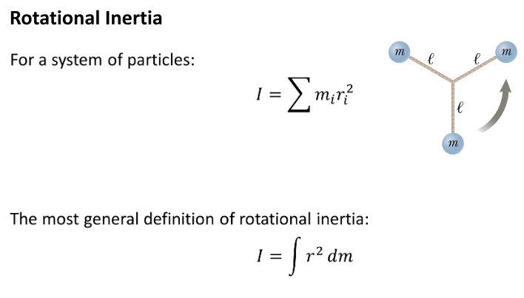
  + 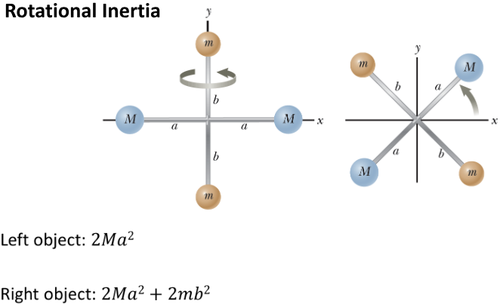
  + 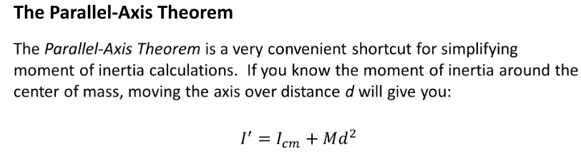
  + 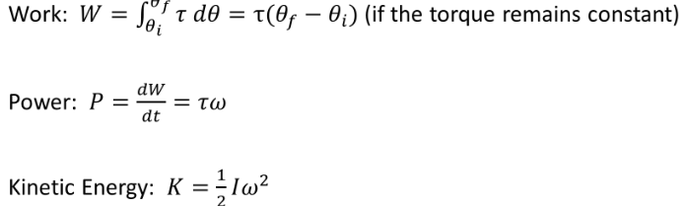
  + 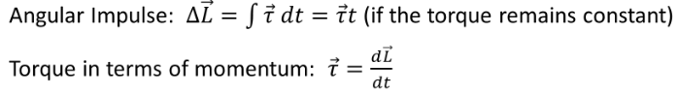
* Unit 6: Harmonic Motion
  + 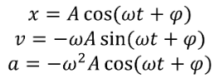
  + 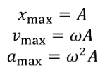
  + 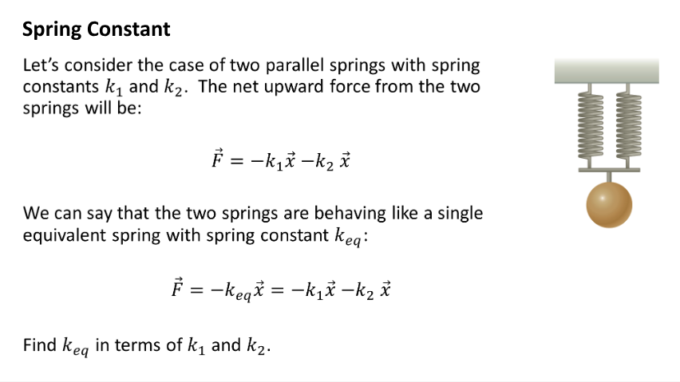
  + 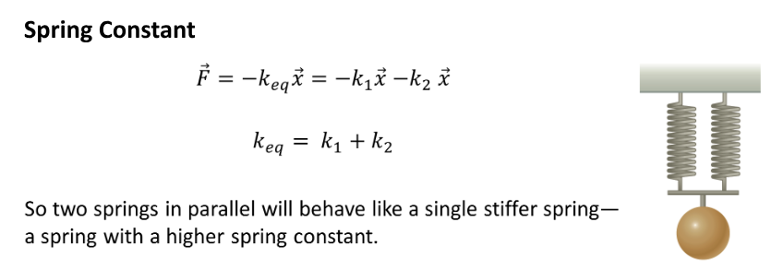
  + 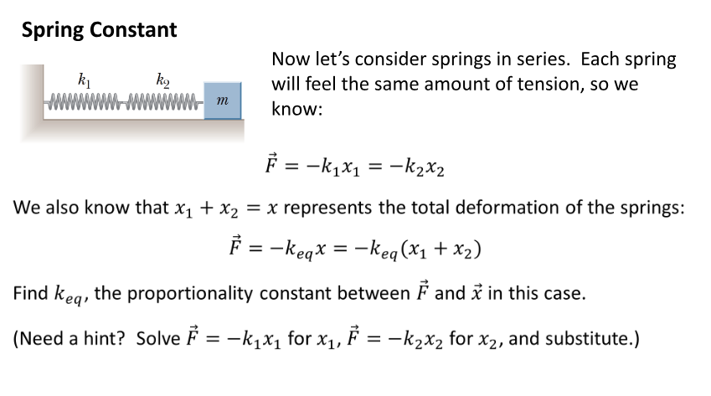
  + 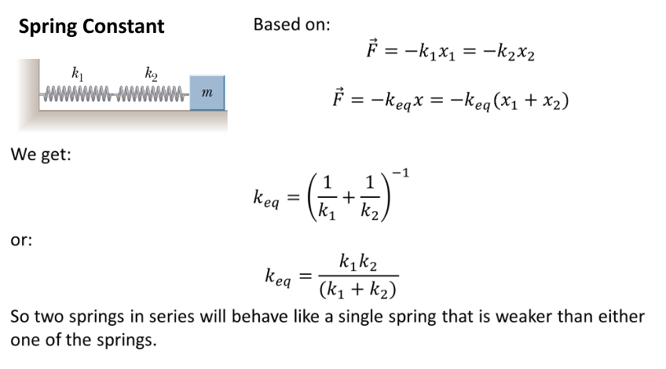
  + For spring: 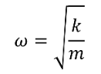
    -  is angular frequency
  + Physical pendulums (string is not massless and therefore its weight exerts torque)
    - 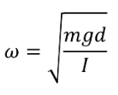 ← you can use this to figure out the period of the simple pendulum!
  + Torsional Pendulum
    - 
    - 
* Unit 7: Gravitation
  + 